Exercise 1: Configuring a Basic Spring Application
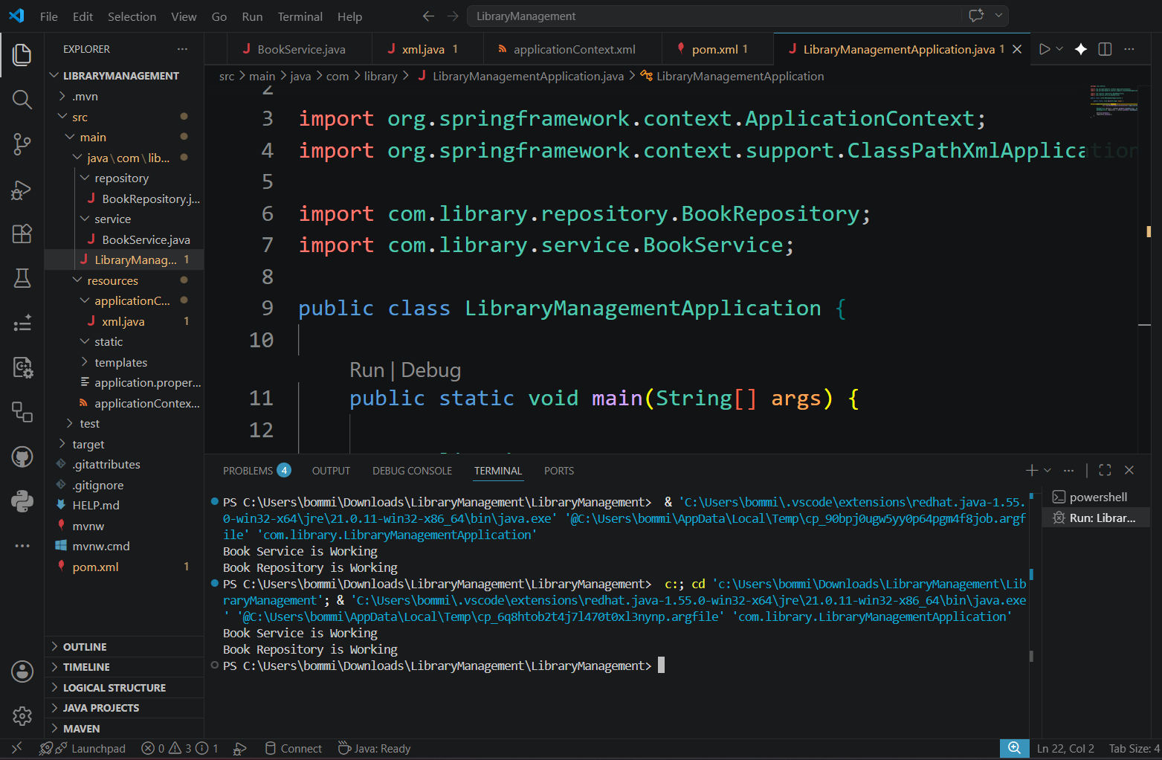
BookRepository.java
package com.library.repository;
public class BookRepository {
public void display() {
System.out.println("Book Repository is Working");
}
}
BookService.java
package com.library.service;

public class BookService {

public void display() {
System.out.println("Book Service is Working");
}
}
applicationContext.xml
<?xml version="1.0" encoding="UTF-8"?>

<beans xmlns="http://www.springframework.org/schema/beans"
xmlns:xsi="http://www.w3.org/2001/XMLSchema-instance"
xsi:schemaLocation="
http://www.springframework.org/schema/beans
https://www.springframework.org/schema/beans/spring-beans.xsd">

<bean id="bookRepository"
class="com.library.repository.BookRepository"/>

<bean id="bookService"
class="com.library.service.BookService"/>

</beans>
LibraryManagementApplication.java
package com.library;

import org.springframework.context.ApplicationContext;
import org.springframework.context.support.ClassPathXmlApplicationContext;

import com.library.repository.BookRepository;
import com.library.service.BookService;

public class LibraryManagementApplication {

public static void main(String[] args) {

ApplicationContext context =
new ClassPathXmlApplicationContext("applicationContext.xml");

BookService service = context.getBean("bookService", BookService.class);
BookRepository repository = context.getBean("bookRepository", BookRepository.class);

service.display();
repository.display();
}
}

Exercise 2: Implementing Dependency Injection
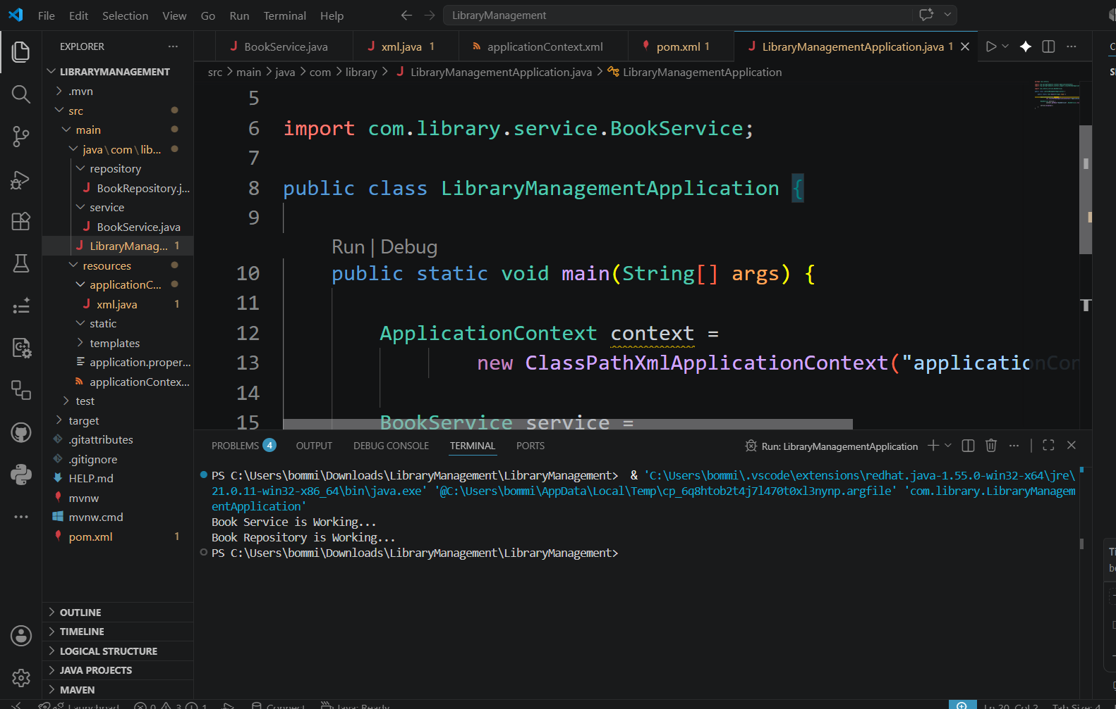
BookService.java
package com.library.service;
import com.library.repository.BookRepository;
public class BookService {
private BookRepository bookRepository;
// Setter Injection
public void setBookRepository(BookRepository bookRepository) {
this.bookRepository = bookRepository;
}
public void display() {
System.out.println("Book Service is Working...");
bookRepository.display();
}
}

BookRepository.java
package com.library.repository;
public class BookRepository {
public void display() {
System.out.println("Book Repository is Working...");
}
}
applicationContext.xml
<?xml version="1.0" encoding="UTF-8"?>
<beans xmlns="http://www.springframework.org/schema/beans"
xmlns:xsi="http://www.w3.org/2001/XMLSchema-instance"
xsi:schemaLocation="
http://www.springframework.org/schema/beans
https://www.springframework.org/schema/beans/spring-beans.xsd">
<!-- Repository Bean -->
<bean id="bookRepository"
class="com.library.repository.BookRepository"/>

<!-- Service Bean -->
<bean id="bookService"
class="com.library.service.BookService">
<property name="bookRepository" ref="bookRepository"/>
</bean>
</beans>
LibraryManagementApplication.java
package com.library;

import org.springframework.context.ApplicationContext;
import org.springframework.context.support.ClassPathXmlApplicationContext;

import com.library.service.BookService;

public class LibraryManagementApplication {

public static void main(String[] args) {

ApplicationContext context =
new ClassPathXmlApplicationContext("applicationContext.xml");

BookService service =
context.getBean("bookService", BookService.class);

service.display();
}
}

Exercise 4: Creating and Configuring a Maven Project
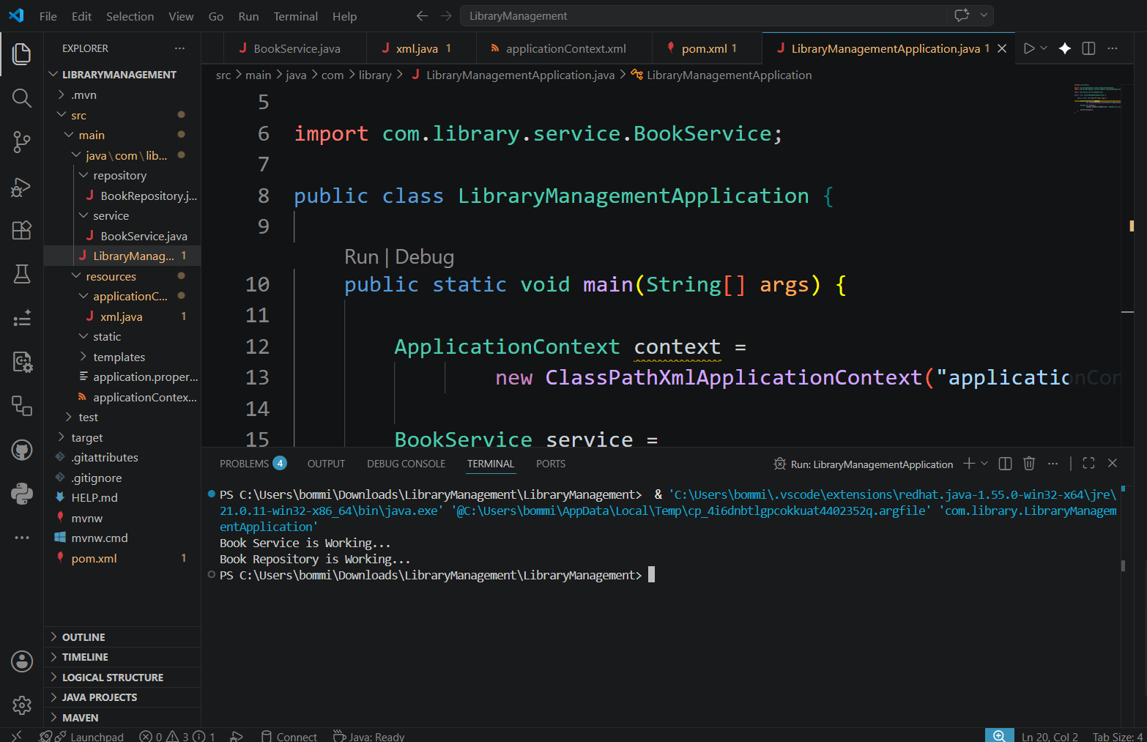
pom.xml
<?xml version="1.0" encoding="UTF-8"?>
<project xmlns="http://maven.apache.org/POM/4.0.0"
xmlns:xsi="http://www.w3.org/2001/XMLSchema-instance"
xsi:schemaLocation="http://maven.apache.org/POM/4.0.0
https://maven.apache.org/xsd/maven-4.0.0.xsd">
<modelVersion>4.0.0</modelVersion>
<groupId>com.library</groupId>
<artifactId>LibraryManagement</artifactId>
<version>1.0</version>
<properties>
<maven.compiler.source>1.8</maven.compiler.source>
<maven.compiler.target>1.8</maven.compiler.target>
</properties>
<dependencies>
<!-- Spring Context -->
<dependency>
<groupId>org.springframework</groupId>
<artifactId>spring-context</artifactId>
<version>5.3.30</version>
</dependency>
<!-- Spring AOP -->
<dependency>
<groupId>org.springframework</groupId>
<artifactId>spring-aop</artifactId>
<version>5.3.30</version>
</dependency>
<!-- AspectJ Weaver -->
<dependency>
<groupId>org.aspectj</groupId>
<artifactId>aspectjweaver</artifactId>
<version>1.9.22</version>
</dependency>
<!-- Spring Web MVC -->
<dependency>
<groupId>org.springframework</groupId>
<artifactId>spring-webmvc</artifactId>
<version>5.3.30</version>
</dependency>
</dependencies>
<build>
<plugins>
<!-- Maven Compiler Plugin -->
<plugin>
<groupId>org.apache.maven.plugins</groupId>
<artifactId>maven-compiler-plugin</artifactId>
<version>3.11.0</version>
<configuration>
<source>1.8</source>
<target>1.8</target>
</configuration>
</plugin>
</plugins>
</build>
</project>
LibraryManagementApplication.java
package com.library;
import org.springframework.context.ApplicationContext;
import org.springframework.context.support.ClassPathXmlApplicationContext;

import com.library.service.BookService;
public class LibraryManagementApplication {
public static void main(String[] args) {
ApplicationContext context =
new ClassPathXmlApplicationContext("applicationContext.xml");
BookService service =
context.getBean("bookService", BookService.class);
service.display();
}
}
Exercise 5: Configuring the Spring IoC Container
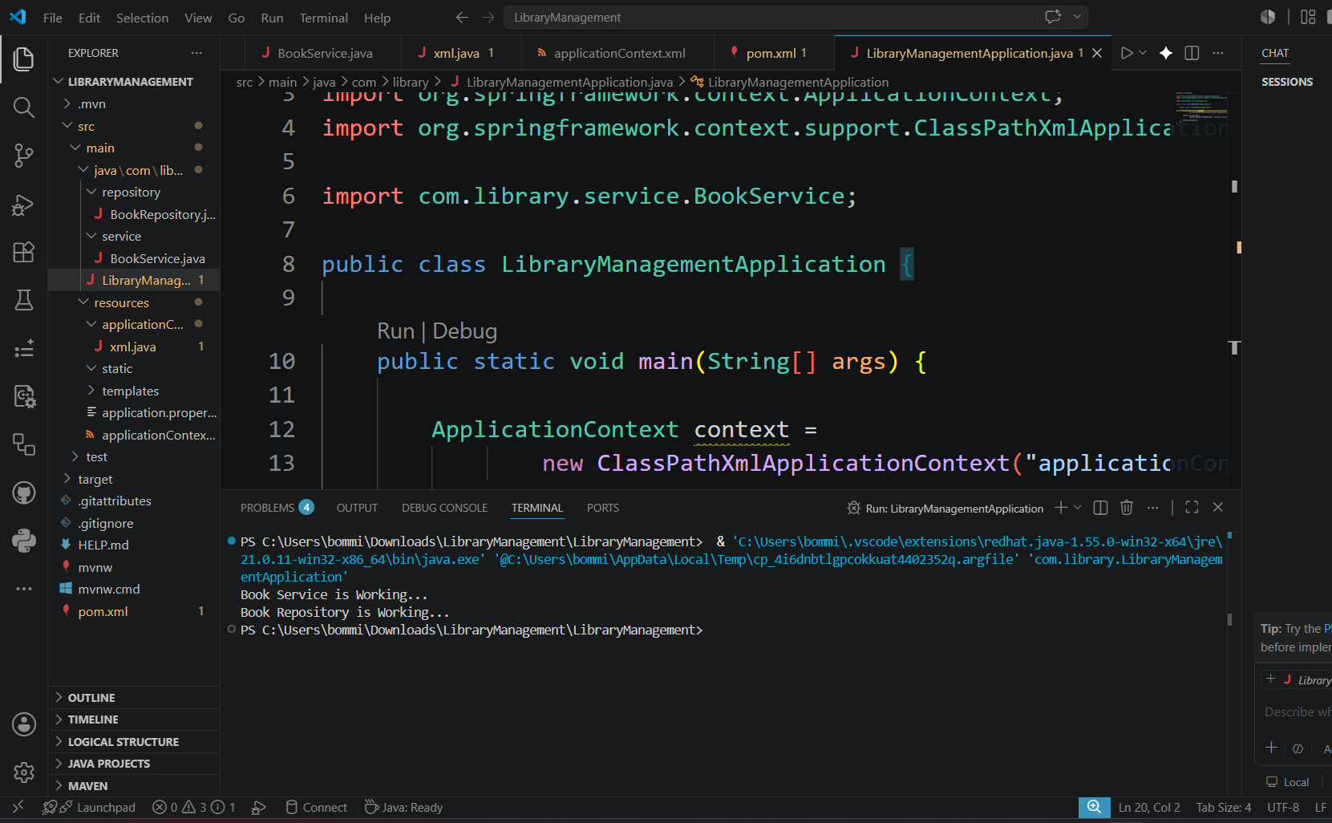

BookRepository.java
package com.library.repository;
public class BookRepository {
public void display() {
System.out.println("Book Repository is Working...");
}
}
BookService.java
package com.library.service;
import com.library.repository.BookRepository;
public class BookService {
private BookRepository bookRepository;
// Setter Injection
public void setBookRepository(BookRepository bookRepository) {
this.bookRepository = bookRepository;
}
public void display() {
System.out.println("Book Service is Working...");
bookRepository.display();
}
}
applicationContext.xml
<?xml version="1.0" encoding="UTF-8"?>
<beans xmlns="http://www.springframework.org/schema/beans"
xmlns:xsi="http://www.w3.org/2001/XMLSchema-instance"
xsi:schemaLocation="
http://www.springframework.org/schema/beans
https://www.springframework.org/schema/beans/spring-beans.xsd">
<!-- Repository Bean -->
<bean id="bookRepository"
class="com.library.repository.BookRepository"/>
<!-- Service Bean -->
<bean id="bookService"
class="com.library.service.BookService">
<property name="bookRepository" ref="bookRepository"/>
</bean>
</beans>
LibraryManagementApplication.java
package com.library;
import org.springframework.context.ApplicationContext;
import org.springframework.context.support.ClassPathXmlApplicationContext;
import com.library.service.BookService;
public class LibraryManagementApplication {
public static void main(String[] args) {
ApplicationContext context =
new ClassPathXmlApplicationContext("applicationContext.xml");
BookService service =
context.getBean("bookService", BookService.class);
service.display();
} }
Exercise 7: Implementing Constructor and Setter Injection
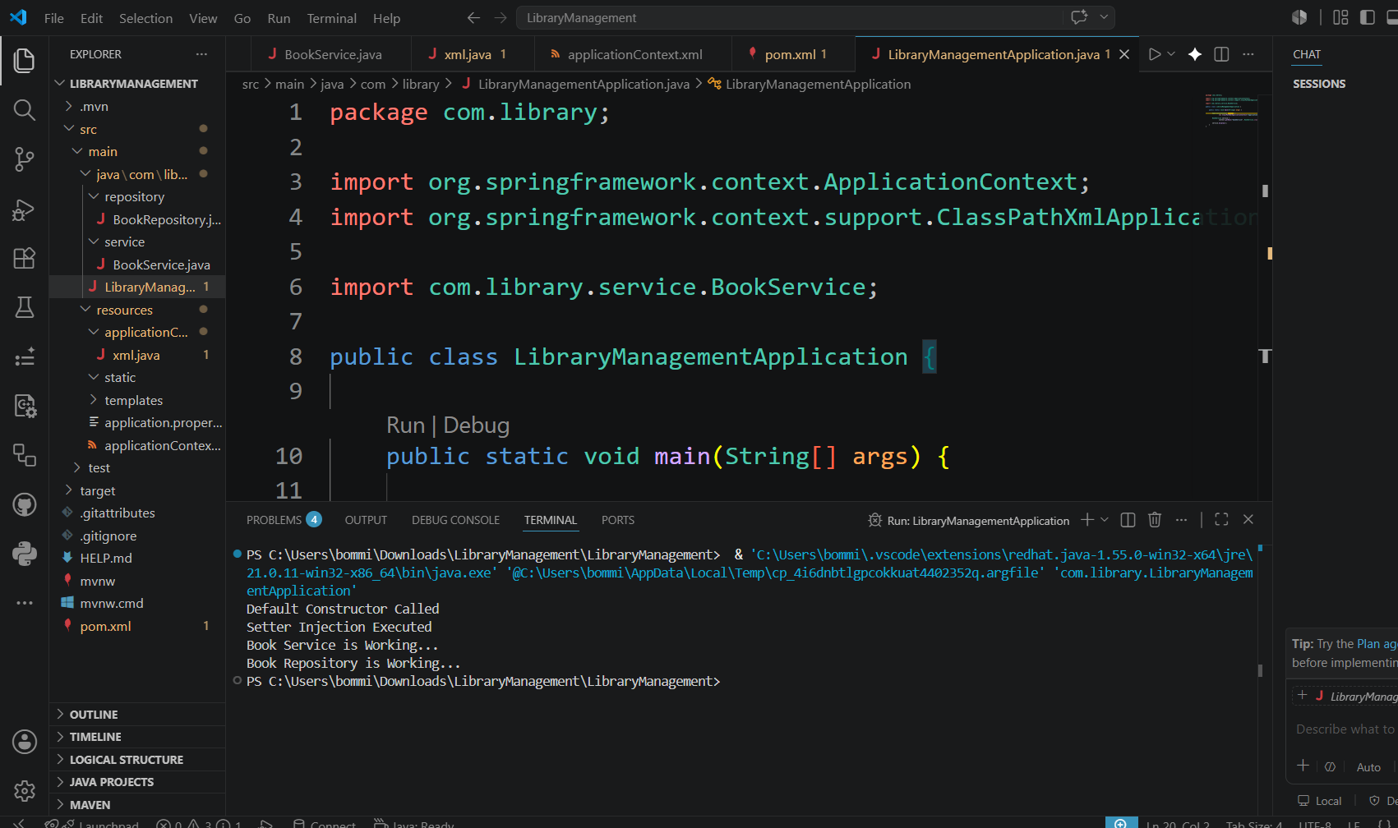
BookRepository.java
package com.library.repository;
public class BookRepository {
public void display() {
System.out.println("Book Repository is Working...");
}
}
BookService.java
package com.library.service;
import com.library.repository.BookRepository;
public class BookService {
private BookRepository bookRepository;
// Default Constructor
public BookService() {
System.out.println("Default Constructor Called");
}
// Constructor Injection
public BookService(BookRepository bookRepository) {
this.bookRepository = bookRepository;
System.out.println("Constructor Injection Executed");
}
// Setter Injection
public void setBookRepository(BookRepository bookRepository) {
this.bookRepository = bookRepository;
System.out.println("Setter Injection Executed");
}
public void display() {
System.out.println("Book Service is Working...");
bookRepository.display();
}
}
applicationContext.xml
<?xml version="1.0" encoding="UTF-8"?>
<beans xmlns="http://www.springframework.org/schema/beans"
xmlns:xsi="http://www.w3.org/2001/XMLSchema-instance"
xsi:schemaLocation="
http://www.springframework.org/schema/beans
https://www.springframework.org/schema/beans/spring-beans.xsd">
<!-- Repository Bean -->
<bean id="bookRepository"
class="com.library.repository.BookRepository"/>

<!-- Service Bean -->
<bean id="bookService"
class="com.library.service.BookService">
<!-- Setter Injection -->
<property name="bookRepository"
ref="bookRepository"/>
</bean>
</beans>
Exercise 9: Creating a Spring Boot Application
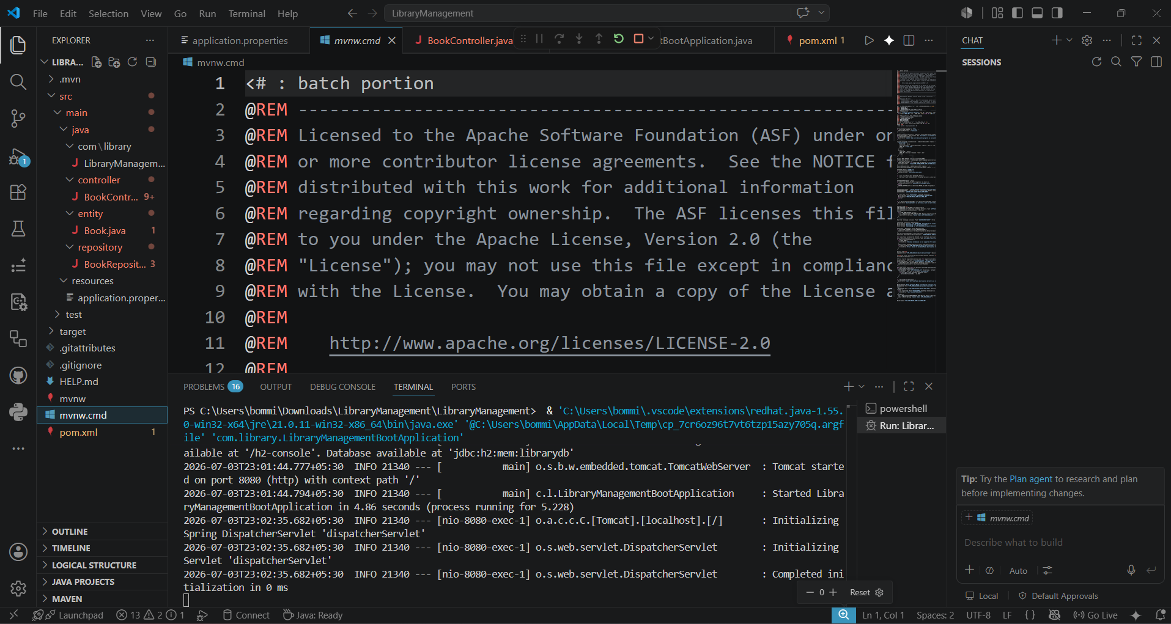
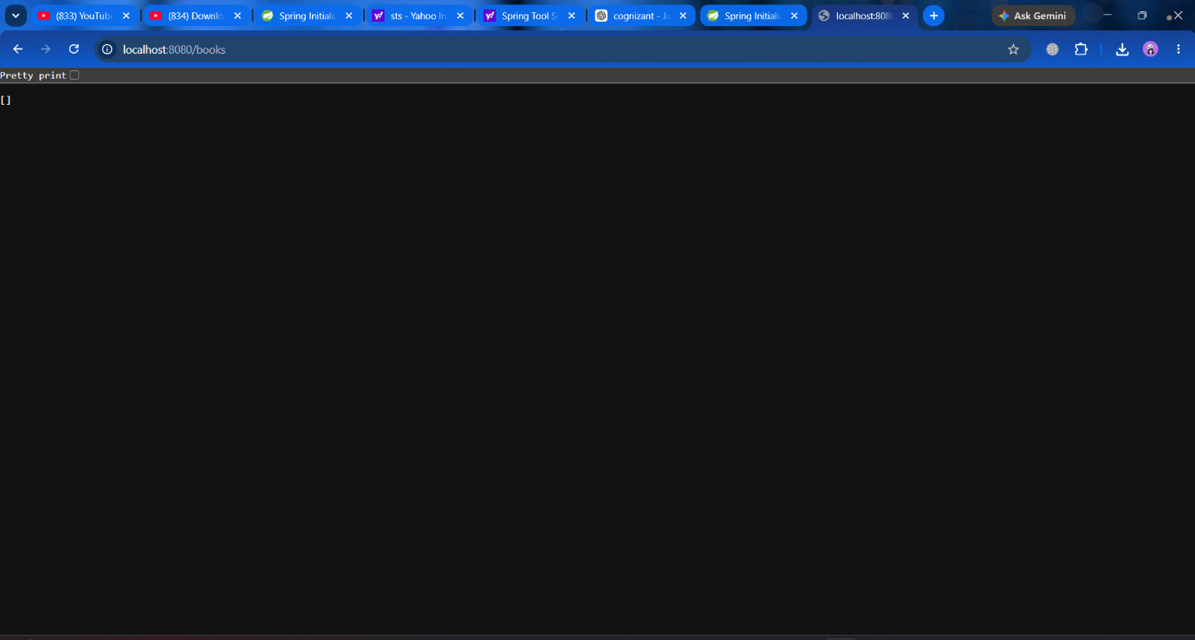
get [] as the output. database has no books

